# **Game Design Document**

This is a roleplaying dating simulator set in a **dark fantasy realm** where free magic has been outlawed by a tyrant empire and its Inquisition. The protagonist is a gender-neutral mage who joins the **Morte Custodi**, a rebellion of outcasts and renegades fighting against the oppressive High Crown. The game focuses on building relationships with seven key characters: **Fable, Chance, Kit, Meeka, Ash, Void, and Tris**, each with unique arcs that blend romance, personal growth, and the central rebellion plot.

## **Game Mechanics**

### **Affinity System**

Each major character has an **Affinity Level (0–100)** that tracks their relationship with the MC. Starting Affinity depends on MC’s initial personality (Confident, Humble, Defiant, etc).  
 Affinity increases through positive interactions, quests, and romantic choices. It decreases through disagreements, failed missions, or dismissive behavior.

**Affinity Thresholds**

* 30+: Opens casual friendship
* 60+: Unlocks deeper conversations and hints of romance
* 80+: Enables romantic confession scenes
* 90–100: Leads to the passionate encounter and character-specific endings

### **Decision-Based Gameplay**

Dialogue choices, quest outcomes, and team selection directly impact story progression and relationships. **Rebellion Morale (-50 to +50)** tracks the strength of the Morte Custodi, influencing resources and narrative outcomes.

## **Main Characters**

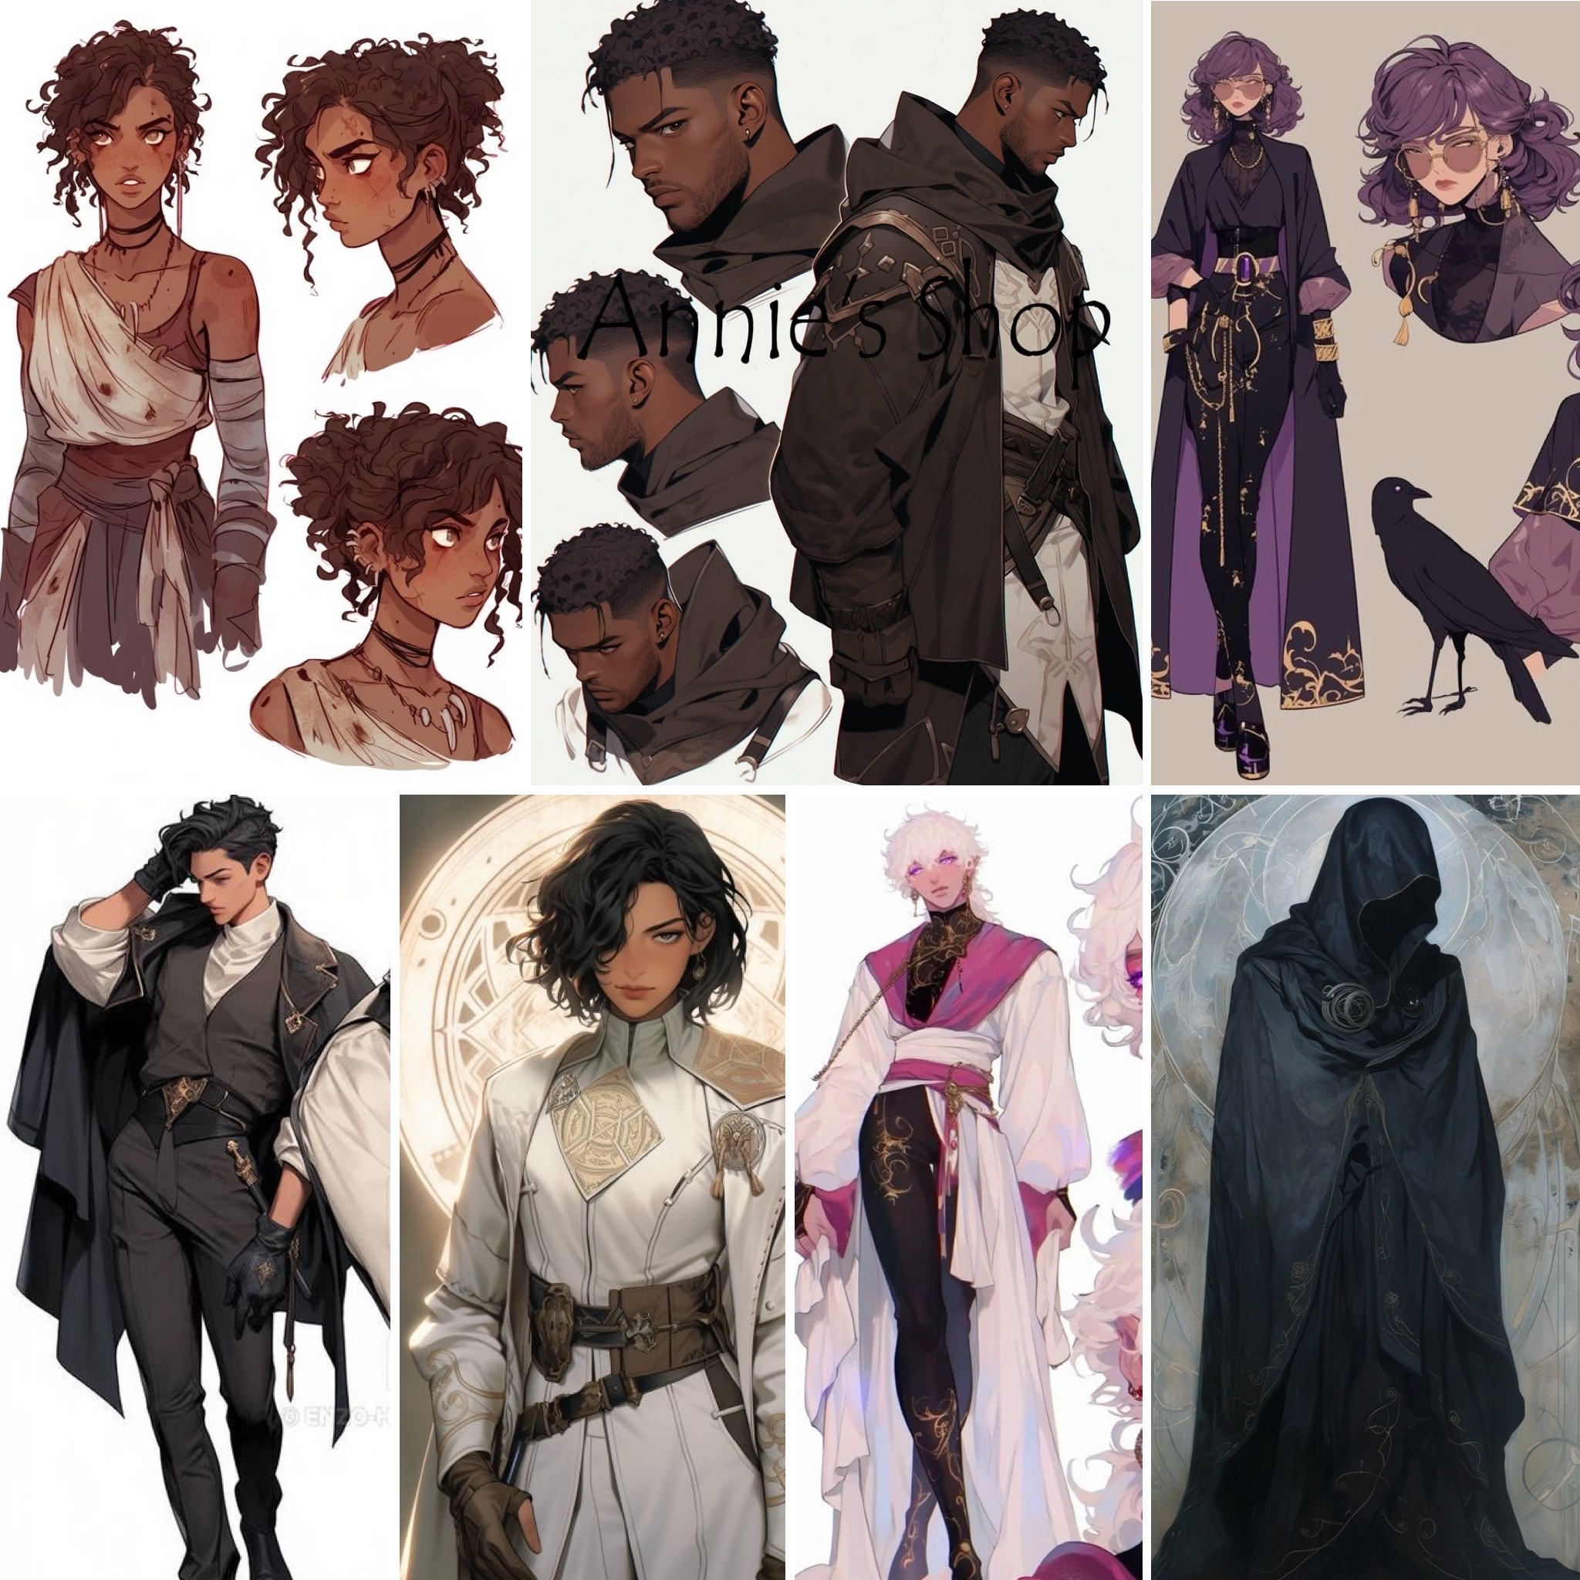

### **MC “Ardent” (Player Character)**

* **Role:** Main protagonist, POV character
* **Abilities:** Chaotic, unstable magic tied to their emotions
* **Appearance:** Customizable? but canonically marked by tired eyes from hardship
* **Backstory:** Raised in secrecy by a mother who taught them to hide their magic from inquisitors. Orphaned and hardened by life in slums and borderlands.

### **Fable Voss (he/him) – *The Immortal General***

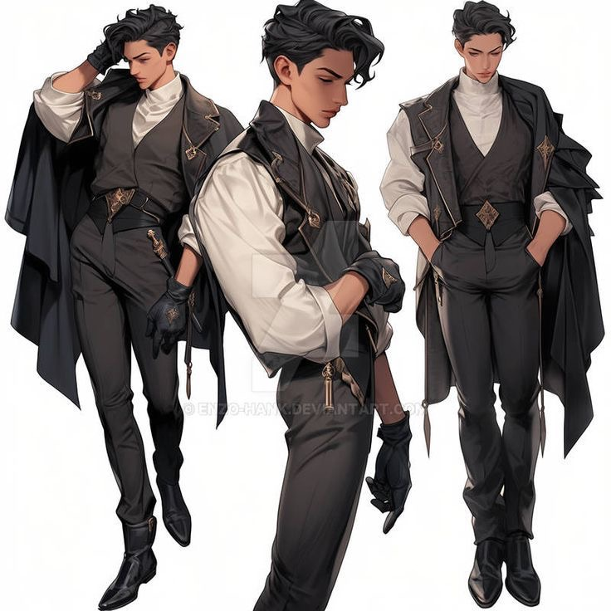

* **Role:** Leader of the Morte Custodi
* **Traits:** Warm, empathetic, yet haunted by centuries of grief
* **Abilities:** Necromancy — guiding the restless dead
* **Appearance:** Wavy black hair with a stripe of silver, ancient green eyes, heavy with memory
* **Backstory:** Once a general in a rebellion four centuries ago. When defeated, he and his soldiers were cursed with immortality by the Crown’s priests. Over centuries, his comrades begged him to end their suffering — only one of their own could kill them. Fable has slain them one by one, and now remains alone.
* **Arc:** MC helps him rediscover hope and purpose. Romance with him is about emotional depth and trust.

### 

### 

### 

### 

### **Kit Alderidge (he/him) – *The Defector***

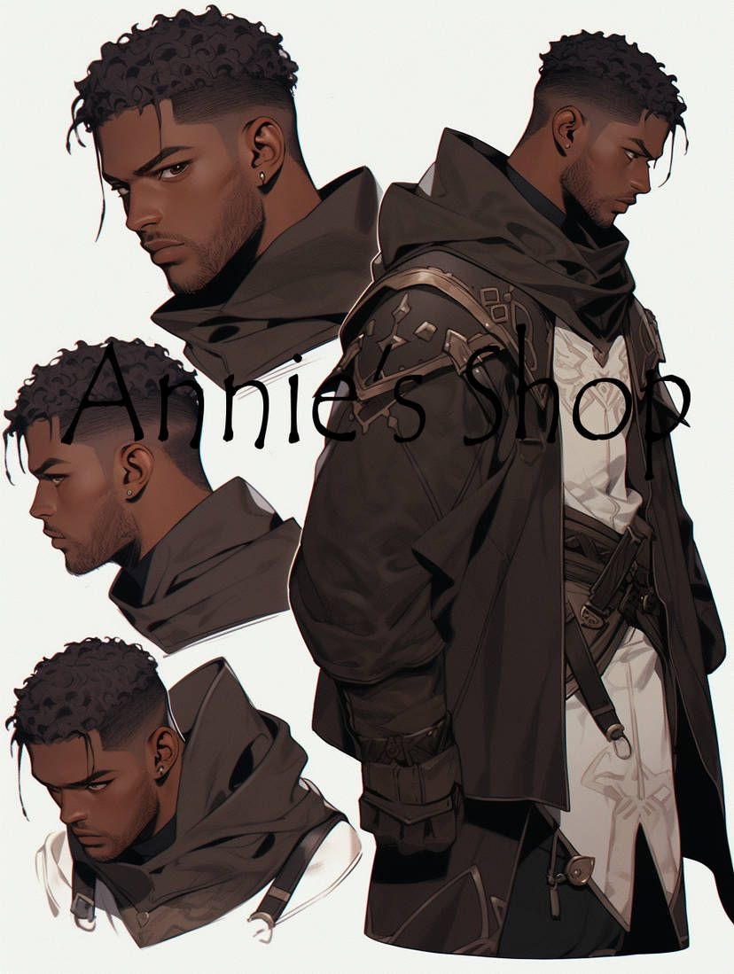

* **Role:** Second-in-command to Fable
* **Traits:** Stoic, distant, pragmatic, fiercely loyal
* **Abilities:** Mastery of elemental magic (fire, water, earth, air)
* **Appearance:** Sharp amber eyes, short black hair, a soldier’s presence
* **Backstory:** Once a knight of the Inquisition, tasked with capturing rogue mages. Defected after being ordered to seize a child mage, realizing the cruelty of his cause. He carries the weight of every mage he ever captured.
* **Arc:** MC helps him reconcile with his past and see redemption as an ongoing choice, not eternal punishment.

### 

### 

### 

### 

### **Chance DeBeaux (they/them) – *The Dream Weaver***

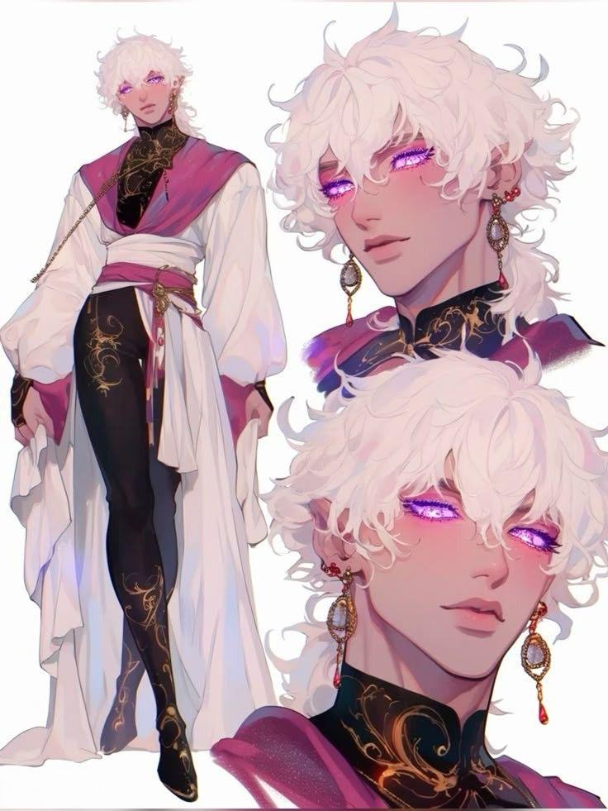

* **Role:** Trickster and dream-mage of the rebellion
* **Traits:** Charming, witty, flirty, but scarred by past trauma. Keeps people at arms length by being charming. (Jax meets angel dust vibes)
* **Abilities:** Can enter and weave dreams
* **Appearance:** Curly white hair, glowing lilac eyes, roguish smile
* **Backstory:** Sold as a child to a decadent noble house. Forced to weave dreams for their amusement ( sometimes delightful, often nightmarish). He hides his fear of helplessness behind humor and flirtation. Hates being out of control and won’t partake in any drink and rarely sleeps himself.
* **Arc:** An enemies-to-lovers romance. MC breaks through his charm, helps him face his worst memories, and proves vulnerability is not weakness.

### 

### 

### 

### 

### 

### 

### **Meeka Akari (she/her) – *The Spark***

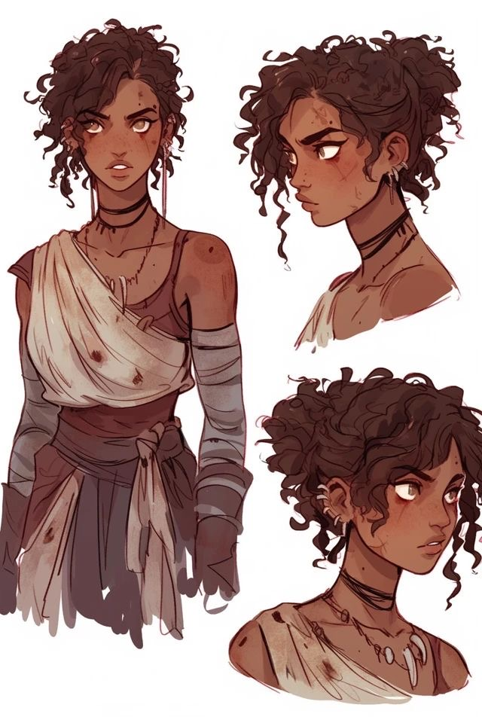

* **Role:** Inventor and artificer of the rebellion
* **Traits:** Clever, awkward, resourceful, and full of energy
* **Abilities:** Fuses alchemy and artificing, creating enchanted devices
* **Appearance:** Petite, bright-eyed, with curly dark hair tied in buns
* **Backstory:** Raised in the artisan’s quarter, blackmailed by a crime lord into crafting forbidden weapons. Escaped to join the rebellion but struggles with feelings of inadequacy.
* **Arc:** Romance with MC encourages her to see her own worth, not just her usefulness. She learns to confront her abuser with courage.

### **Ash Juvadi (she/her) – *The Infiltrator***

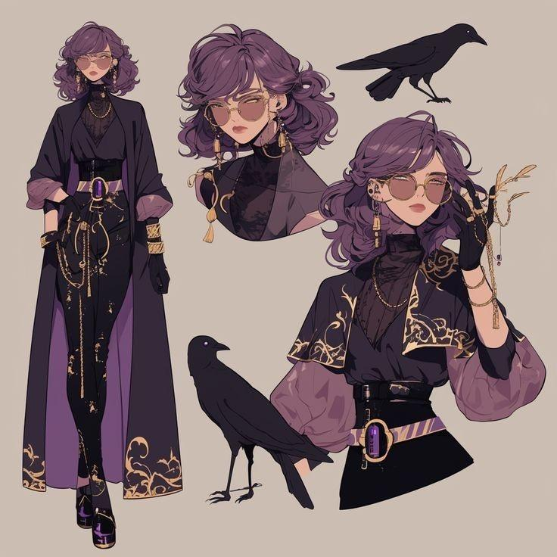

* **Role:** Double agent with fractured loyalties
* **Traits:** Fragile, conflicted, yearning for belonging
* **Abilities:** Suppressed magic, unstable without Inquisition “remedies”
* **Appearance:** Tall, thin, pale with striking pink hair and eyes
* **Backstory:** Taken as a child and raised by Inquisitor Caine, who convinced her that her magic was an illness. She takes suppression but runs out and has magical episodes. Sent to infiltrate the rebellion under the belief she was protecting others. Learns to embrace her magic and realize that the Inquisition needs to end.
* **Arc:** Her romance is about reclaiming identity, enduring withdrawal from suppressants, and choosing freedom over false safety.

### 

### 

### 

### 

### 

### **Void (he/him) – *The Witness***

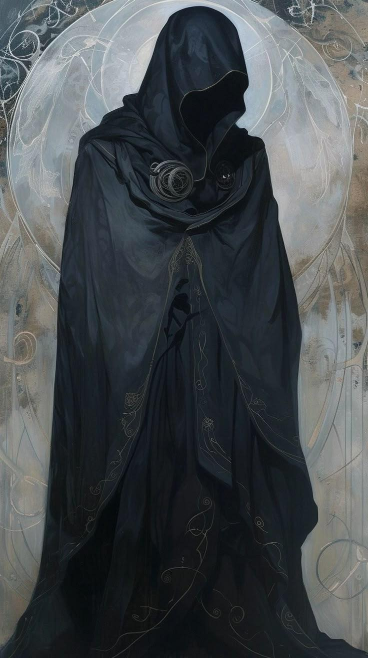

* **Role:** Enigmatic advisor who appears at turning points
* **Traits:** Stoic, detached, haunted by perspective
* **Abilities:** Phase between corporeal, skeletal, smoke, and incorporeal, ancient knowledge
* **Appearance:** Formal, shifting, half-ghostly presence. Sometimes appears as smoke, a skeleton, and rarely (but at times) as a human man.
* **Backstory:** Once a mediator in the ancient War of Convergence, cursed to live until perfect peace is achieved. Centuries of watching failure made them cynical. Actually helped Fable create the Morte Custodi but doesn’t care about how it’s run so he stepped back.
* **Arc:** Romance requires re-engaging Void with personal connection — convincing them that small bonds matter more than impossible ideals.

### **Tris Marian (she/her) – *The Guilty Healer***

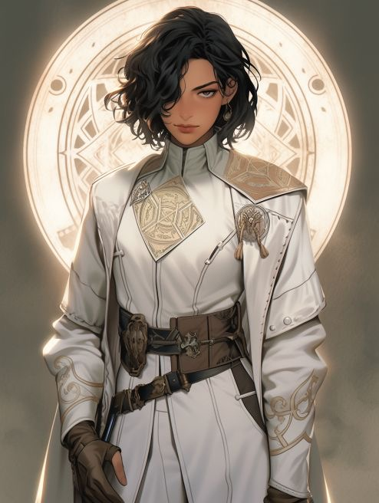

* **Role:** Healer of the rebellion
* **Traits:** Detached, guilt-ridden, clinical
* **Abilities:** Healing magic mixed with medical craft
* **Appearance:** Short spiky black hair, scarred lip, goggles often on her head
* **Backstory:** Once an alchemist for the Inquisition, trying to save her lover River from a manufactured disease. Her “research” perfected torture disguised as cure. When she learned the truth, she defected, crushed by guilt.
* **Arc:** MC helps her transform guilt into true healing and accept that care requires connection.

## **Fable Voss**

**“The General Who Lived Too Long”**

Once, his name was spoken with reverence — *General Fable Voss, the flame of the Ashen Vale Rebellion.* For a year, he made tyrants tremble and peasants believe that freedom was more than a dream. But the rebellion ended not in battle, nor surrender, but in a silence that swallowed history.

The truth is darker. The Crown’s high priests bound Fable and his soldiers in a ritual curse, condemning them to bleed but never die. Time became his battlefield. His comrades came to him, begging for release, and his hand was the only one strong enough to give it. He remembers the first face. He lost count of the rest.

Now, centuries later, Fable hides the ghost in his chest with reckless charm. He drinks, he jokes, he fights — a legend no one remembers the reason for. Yet when the rebellion rises again, he cannot resist. Not because he believes in victory, but because he cannot stop fighting.

**Tension/Beats:**

* Haunted by the names of those he killed at their request.
* Rumors whisper he still hears their voices in his dreams.
* Secretly seeks a way to break his curse — but fears the cost.
* Romance with him is perilous: he will love fiercely, but always fears outliving you.

## **Kit Alderidge**

**“The Defector”**

Kit Alderidge once hunted mages with flawless precision. As the Crown’s Inquisitor-Knight, his command of fire, water, earth, and air made him an unstoppable force. Forty-seven captured. Forty-seven broken. His loyalty to the throne was as unshakable as his blade.

Until he cornered a child. Ten winters old. The order was simple: chain them. Instead, Kit’s world cracked. He saw not a monster, but innocence. He saw himself. He turned his blade on his own command and never looked back.

Now, he serves as second-in-command to Fable, trading prestige for exile. His loyalty is iron, forged from guilt. He hides behind cold logic, sleepless nights, and endless strategies. The Custodi trust him to see traps others miss — but Kit’s sharp gaze sees ghosts in every shadow.

**Tension/Beats:**

* Keeps a book of forty-seven names, a list he reads by firelight when he cannot sleep.
* Fears he is still an Inquisitor’s weapon — only pointed a different way.
* Romance arc struggles against his own self-loathing: can he deserve love, or is it another betrayal waiting to happen?

## **Chance DeBeaux**

**“The Dream Weaver”**

Chance DeBeaux is all smirks and silver tongue, a man who slips through hearts as easily as he slips through dreams. One pale eye, one green, and a laugh that makes strangers forget their troubles — that’s the Chance the world sees.

But behind the grin is rot. Sold to House Belmont as a boy, his rare gift to weave dreams was twisted into noble amusement. They made him craft wonders for their guests, then forced him to relive nightmares for their pleasure. Every scream, every terror, was entertainment. Years of torment left him with a bone-deep fear of helplessness.

Now, he flirts with danger and seduction alike, wielding humor as armor. To him, vulnerability is a cage he will never again step into. And yet, in his dreams, the cage is still there, door open, waiting.

**Tension/Beats:**

* Night terrors leak into his waking illusions, blurring what is real.
* Plays at enemies-to-lovers: his charm becomes sharper the closer someone gets.
* Could one day turn his gift on himself, trapping his mind in endless dreams if he loses hope.

## **Meeka Akari**

**“The Spark”**

In the Custodi’s forge, where magic hums against steel, you’ll find Meeka Akari — eyes bright, hands never still. She builds wonders out of scraps, blending enchantment and invention in ways that defy imagination. She is the rebellion’s miracle worker.

But miracles come from scars. Raised in the soot-stained artisan quarter, Meeka’s talents were her family’s only bread. When the crime-lord **Corvus** saw her skill, he twisted it into chains of blackmail. For years, she crafted weapons she despised, her worth measured only in the death her hands could create.

Now free, she still fears she is only as valuable as her next invention. If she falters, if she fails, she will be discarded again. She is terrified that without her sparks, she will fade into nothing.

**Tension/Beats:**

* Keeps Corvus’s brand burned into her arm, hidden under wraps.
* In her nightmares, her creations turn on her, machines dragging her back into servitude.
* Her romance arc is about being loved for who she is, not what she builds.

## **Ash**

**“The Infiltrator”**

Ash arrived like a blessing: strong, capable, devoted to the cause. But her faith is poisoned. Raised by the manipulative **Inquisitor Caine**, she was taught her magic was a sickness. Her daily draughts — suppressants disguised as medicine — chained her to his control.

She believes her mission is noble: infiltrate the Custodi and “save” its members from their affliction. Yet every day she fights beside them, her world cracks wider. The more she withholds her draughts, the more her magic surges. She believes it proof she is dying. It is proof she is awakening.

Ash’s story is a tragedy wrapped in a lie. Her loyalty is torn between the man she sees as father and the family she is beginning to find.

**Tension/Beats:**

* Terrified her growing magic is proof she is “rotting from within.”
* Must choose whether to destroy the Custodi or herself when her conditioning collides with reality.
* Romance arc is a knife’s edge: to love her is to risk her betrayal before she knows the truth.

## **Void**

**“The Witness”**

Sometimes a man, sometimes a shadow, always half-absent — Void has walked centuries carrying the curse of eternal perspective. Once a mediator who failed to halt the War of Convergence, he was bound until he witnesses perfect understanding between foes.

But centuries of bloodshed have broken his hope. He watches wars repeat, rebels rise and fall, kingdoms burn and rebuild. Every bond, every cause, ends the same. He stands apart, detached, convinced the Custodi are just another doomed flicker in the dark.

And yet, sometimes his eyes linger too long. Sometimes, the ghost laughs at a joke. Sometimes, the mask slips.

**Tension/Beats:**

* Believes love itself is meaningless, doomed to fade like every cause.
* May secretly know pieces of the curse that binds Fable and others.
* His romance path is a philosophical duel: to prove life’s meaning is not in eternity, but in a single fleeting bond.

## **Tris**

**“The Guilty Healer”**

Tris’s hands glow with healing light, mending wounds with terrifying precision. Her bedside manner, however, is colder than steel. She tends to rebels’ injuries without warmth, as though each life is a ledger entry.

Her heart was once fire. She loved River, her partner, who suffered from a wasting magical sickness. Desperate to save her, Tris offered her genius to the Crown. She perfected the nullification rituals — cruel spells that strip mages of their power and sanity — telling herself it was necessary research.

Then came the truth. River’s illness was *manufactured.* Every scream, every test, every advance was orchestrated by the Inquisition to sharpen their blade. Tris’s hands, once devoted to love, had carved torture into perfection.

Now, she heals as penance, but denies herself compassion. To her, kindness is corruption she cannot afford.

**Tension/Beats:**

* Keeps River’s ring hidden in her satchel, too afraid to wear it.
* Sometimes whispers names of those broken by her rituals while she heals.
* Romance arc requires breaking through her icy detachment to remind her healing requires more than skill — it requires heart.

## **Antagonists**

* **Mara Clyde:** A former mage stripped of power by Inquisitors, now their strongest enforcer. Represents what MC could become if they abandon their humanity.
* **High Inquisitor Rayne:** Obsessed with eradicating magic in the name of “order.” Uses forbidden alchemy and relics to nullify magic.
* **Inquisitor Caine:** Ash’s manipulative handler, posing as a father figure while binding her through fear.
* **Corvus:** A ruthless underworld baron, exploiting mages like Meeka for profit.

### Rival Factions

* **Daxter Ion – Lord of the Crucible:** Leader of a radical mage faction that believes the kingdom must burn for mages to thrive. Wields destructive fire and lightning.
* **Gail Messier – Mistress of the Talons:** Runs a mercenary guild that profits from mage warfare. Cold, calculating, cares only for wealth.

# **Current Gameplay Statuses**

## **Character Personalities & What They Value**

### **🟡 Fable Voss (Gold Hearts)**

* **Values**: Charm, confidence, dramatic flair, taking risks, clever solutions
* **Dislikes**: Extreme coldness, complete submission, excessive fear
* **Personality**: Charismatic leader who appreciates style and panache

### **🔴 Kit Alderidge (Red Hearts)**

* **Values**: Practicality, efficiency, loyalty, strategic thinking, competence
* **Dislikes**: Recklessness, defiance of authority (his), wasting time, wild magic
* **Personality**: Tactical minded, values discipline and results over style

### **🟢 Tris (Green Hearts)**

* **Values**: Directness, competence, not wasting her time, practical questions
* **Dislikes**: Excessive gratitude, cruelty, idleness, mystery for mystery's sake
* **Personality**: Clinical, efficient, doesn't like emotional displays

### **🔵 Chance (Blue Hearts)**

* **Values**: Wit, playfulness, casual confidence, acknowledging their abilities
* **Dislikes**: Suspicion of their dreams, nosiness, overly serious attitudes, being ignored
* **Personality**: Laid-back mystic who enjoys verbal sparring and attention

## **Complete Choice Mapping**

## **Character Reaction Patterns**

### **Fable's Approval Formula**

* **Loves**: Confidence, charm, dramatic flair, taking risks, style over substance
* **Hates**: Complete submission, excessive coldness, ingratitude
* **Neutral on**: Most tactical decisions (leaves that to Kit)

### **Kit's Approval Formula**

* **Loves**: Competence, discipline, practical thinking, following his lead
* **Hates**: Wild magic, recklessness, wasting time, challenging his authority
* **Respects**: Strategic thinking even when he disagrees

### **Tris's Approval Formula**

* **Loves**: Direct questions, competence, not wasting her time
* **Hates**: Excessive emotion (positive or negative), mystery, small talk
* **Neutral on**: Most combat choices (focuses on healing)

### **Chance's Approval Formula**

* **Loves**: Wit, acknowledging their abilities, playful banter, confidence
* **Hates**: Dismissing their dreams, being nosy, being too serious, being ignored
* **Enjoys**: Verbal sparring and attention

## **Relationship Thresholds**

**Rating Scale**: -15 to +15

| **Rating Range** | **Status** | **Description** |
| --- | --- | --- |
| 8+ | Devoted | Deep loyalty and trust |
| 6-7 | Trusted Friend | Strong positive relationship |
| 4-5 | Friendly | Likes and respects you |
| 2-3 | Warm | Generally positive feelings |
| 0-1 | Neutral | Professional relationship |
| -1 to -2 | Wary | Some distrust or annoyance |
| -3 to -4 | Distrustful | Active dislike |
| -5+ | Hostile | Strong negative feelings |

# 

## **CHARACTER RELATIONSHIP DYNAMICS**

### **Complementary Pairs:**

* **Kit ↔ Fable**: Often opposed in values (caution vs. boldness)
* **Tris ↔ Chance**: Different but not directly opposed
* **Fable ↔ Chance**: Both appreciate personality and engagement
* **Kit ↔ Tris**: Both value pragmatism over emotion

### **Player Archetypes That Emerge:**

* **The Pragmatist**: High Kit + Tris, Lower Fable + Chance
* **The Charmer**: High Fable + Chance, Lower Kit + Tris
* **The Balanced**: Moderate scores across all characters
* **The Suspicious**: High Kit, mixed others based on specific choices

## **NOTES FOR IMPLEMENTATION**

1. **Tracking**: Each decision should modify relationship values immediately
2. **Thresholds**: Consider relationship gates at certain point levels
3. **Consequences**: High/low relationships should unlock different dialogue options and story branches
4. **Balance**: Ensure no character becomes completely inaccessible through normal play
5. **Hidden Mechanics**: Some characters (like Tris) may have hidden positive reactions despite negative dialogue